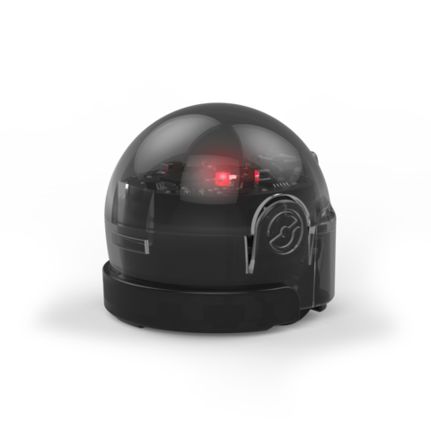
You Can Be An
Ozobot Trainer!

- Watch the Video
- Practice on the Ready to Use tracks
- Select one Ozobot Trainer Racetrack sheet and see how well you can “train” an Ozobot.

1 = RED
2 = GREEN
3 = BLUE
4 = BLACK

