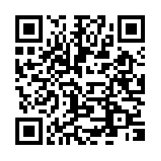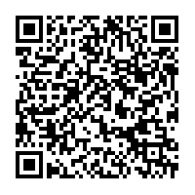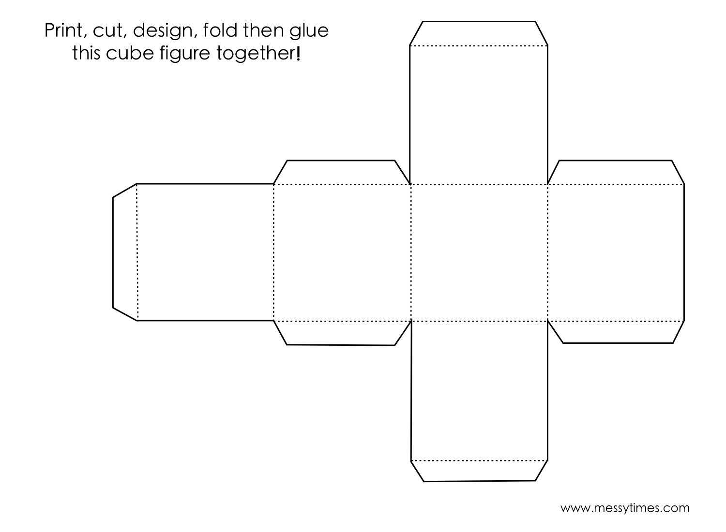

Fara T. Faust copyright ©2015

QR Fraction Cube

1. Cut out the cube following the solid line.
2. Fold along all the dotted lines.
3. Use tape to construct the cube.
4. Roll the cube and scan the codes using the QR scanner on your iPad.

**QR Fraction Cube****MA.1****.1.5** The student will identify the parts of a set that represent fractions for halves, fourths, and thirds and write the fractions. **(SOL 1.3; Number and Number Sense)**

**MA.1.1.6** The student will identify the parts of a region that represent fractions for halves, fourths, and thirds and write the fractions. **(SOL 1.3; Number and Number Sense)**

**Name:**

**________________________________**

iXL

Show 1/3

Show 3/4

video

**Pizza 1**

Find this app on iPad